**Execution Report for Feature: Test1**

Step 1: Launch "Automation_Practice_Url" WebPage - [PASS]

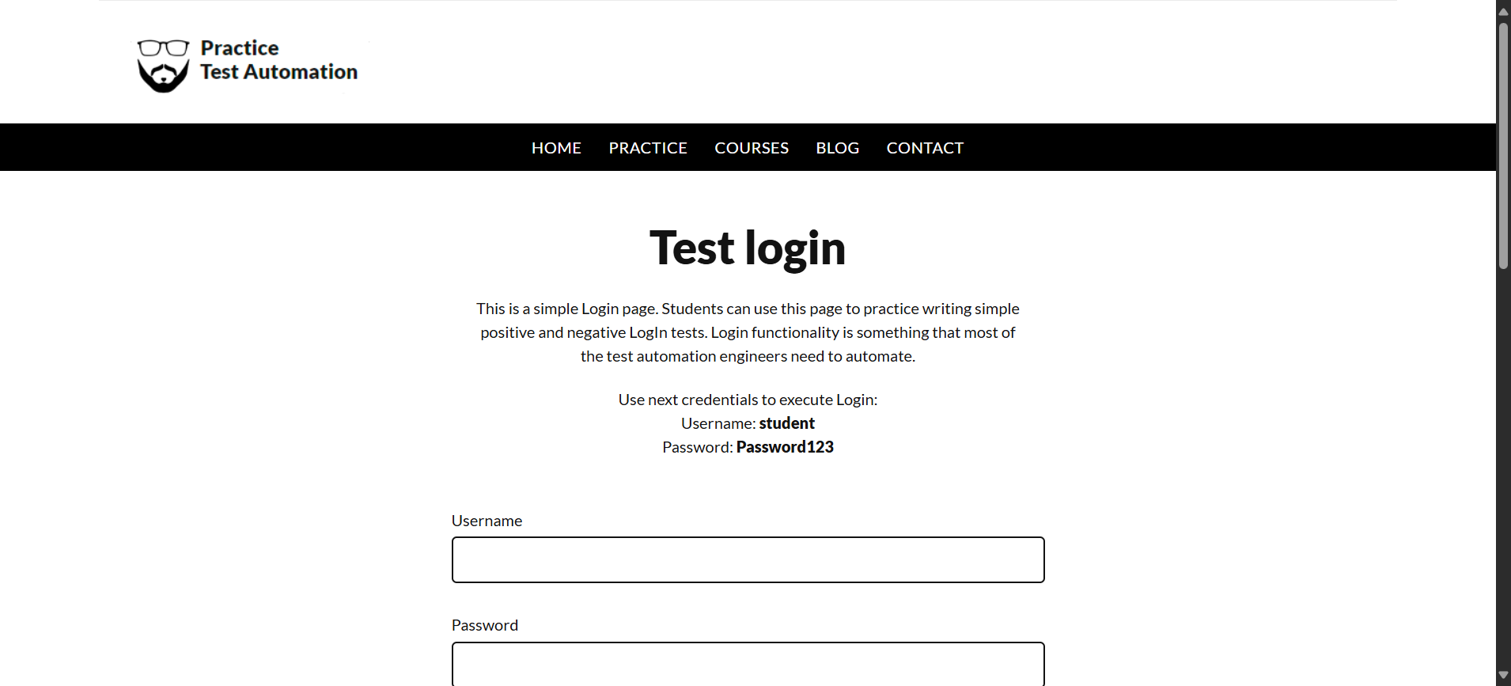

Step 2: Enter UserName "username" into "Username" textbox at "LoginPage" page - [PASS]

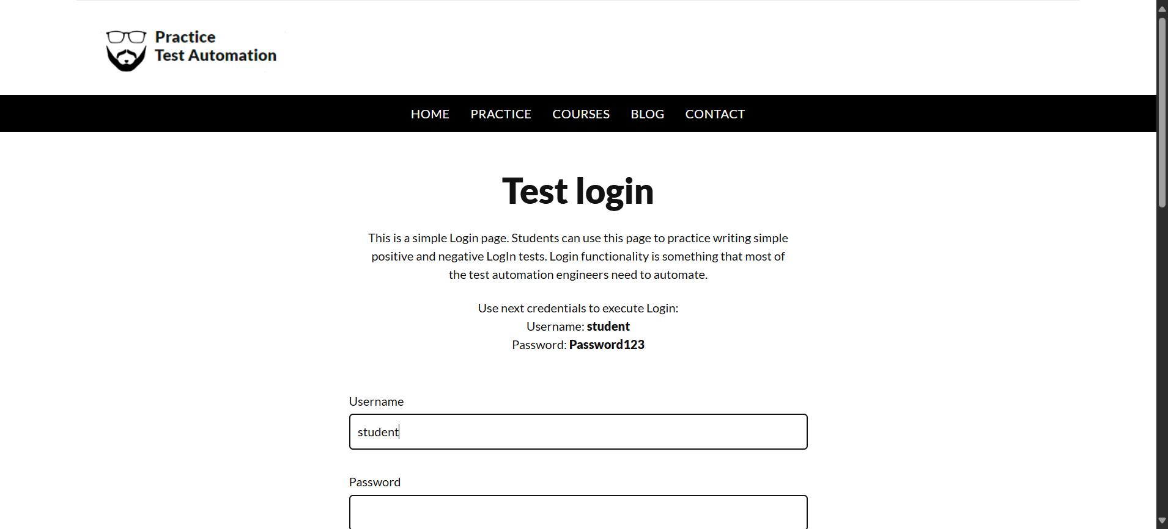

Step 3: Enter Password "password" into "Password" textbox at "LoginPage" page - [PASS]

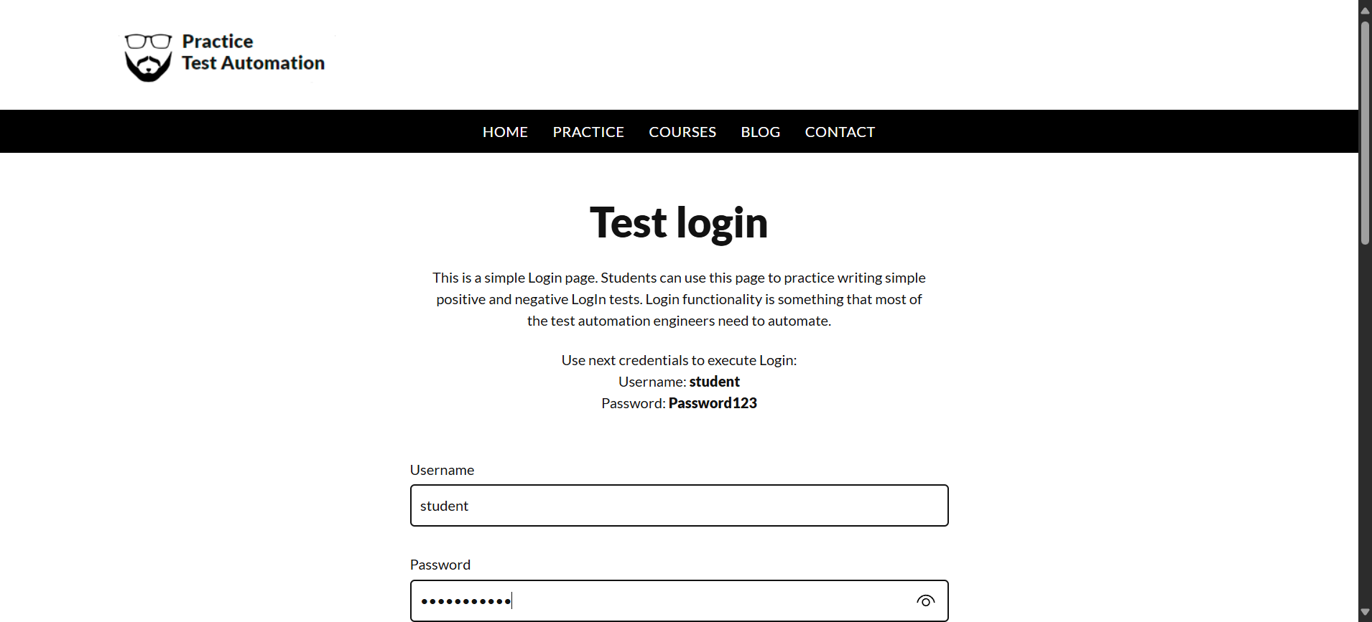

Step 4: Click "login_button" element at "LoginPage" page - [PASS]

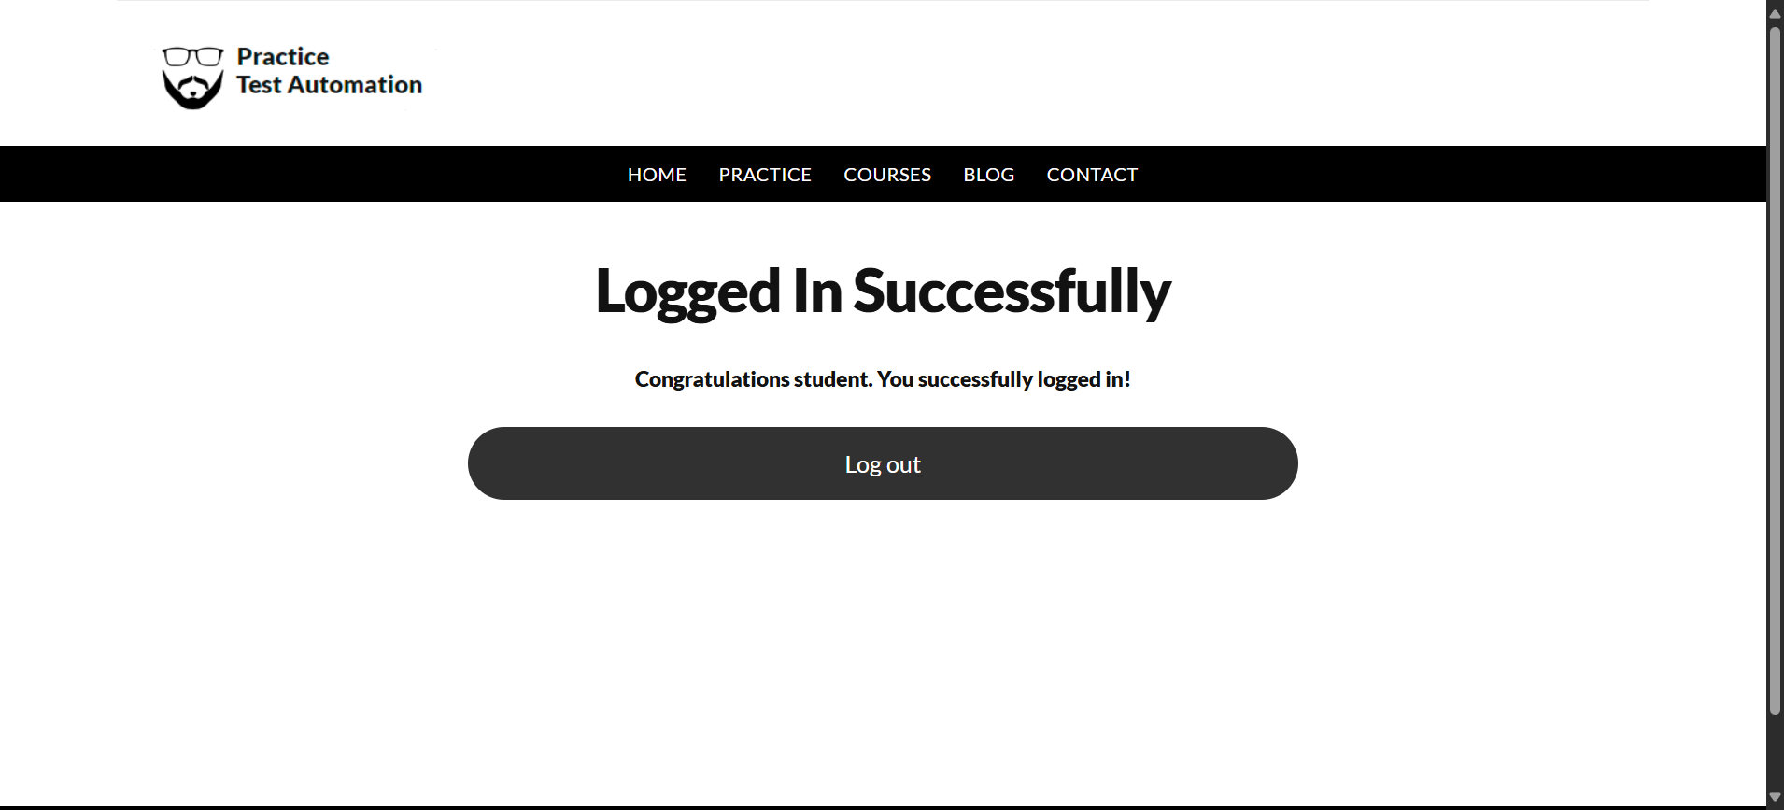

**Summary:  
Total Steps: 4  
Passed Steps: 4  
Failed Steps: 0**